For example, a correlation of r = 0.8 suggests a strong, positive association between two variables, whereas a correlation of r = -0.1 suggests a weak, negative association.

A correlation close to zero suggests no linear association between two continuous variables.

To obtain a measure of the relation between X and Y independent of units of measurements.

Karl Pearson in 1890 developed a measure of relationship and it’s called the Karl Pearson correlation coefficient.

The population correlation denoted as ρ and is called a product-moment correlation  
coefficient of the correlation coefficient.

**Getting Data**

dt <- data.frame(a = rnorm(10) , b = rnorm(10), c = rnorm(10))

head(dt)

a b c d

1 0.8160959 1.2173900 -0.97793080 -0.757270945

2 0.3974761 1.3211291 -0.00980259 0.656894857

3 0.2899615 -0.7997789 -0.71659935 0.488829146

4 0.6998316 0.1078887 0.99519040 -0.379013931

Measure the correlation between all the variables.

corr(dt)

a b c d

a 1.00000000 0.6310367 -0.04332633 -0.3316613

b 0.63103666 1.0000000 -0.27076891 -0.1930333

c -0.04332633 -0.2707689 1.00000000 0.1802828

d -0.33166128 -0.1930333 0.18028278 1.0000000

**Visualization**

Now, will check out how to plot correlation results using sjplot package. Load the package into R

library(sjPlot)

sjp.corr(data)

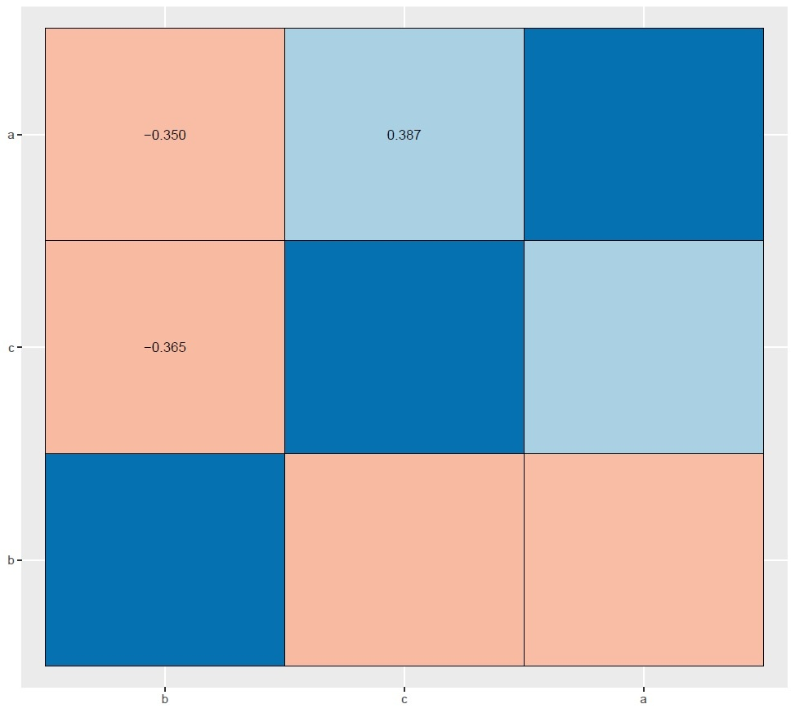

Here pink color indicates a negative correlation and blue color indicates a positive correlation.

When we are doing correlation analysis significance also important.

How to measure significant correlation analysis in R?

Load below-mentioned package for p-value calculation

library(tidyverse)

library(broom)

dt1 = t(combn(names(dt), 2)) %>%

as_data_frame() %>%

setNames(c("x", "y"))

dt1

cor_result = dt1 %>%

mutate(results = map2(x, y, ~ cor.test(dt[[.x]], dt[[.y]], method = "pearson")),

results = map(results, tidy)) %>%

unnest(results)

cor_result

uses the following function to extract estimate and p-value

cor_result %>% select(x, y, estimate, p.value) %>% filter(p.value < 0.5)

x y estimate p.value

<chr> <chr> <dbl> <dbl>

1 a b 0.631 0.0504

2 a d -0.332 0.349

3 b c -0.271 0.449